26.12.13 Editors - Properties Editor - Object Data Properties Tab - Light Object
Preview panel 2
Light panel 2
Point Light 2
Color 2
Power 3
Specular 3
Radius 3
Max Bounces 3
Custom Distance 3
Distance 3
Sun Light 3
Color 3
Strength 3
Specular 3
Angle 3
Max Bounces 4
Spot Light 4
Color 4
Strength 4
Specular 4
Radius 4
Max Bounces 4
Custom Distance 4
Distance 4
Spot shape 4
Size 4
Blend 5
Show cone 5
Area Light 5
Color 5
Power 5
Specular 5
Shape 5
Size X / Y 5
Max Bounces 5
Custom Distance 5
Distance 6
Portal 6
Cast Shadow 6
Multiple Importance 6
Light panel 6
Clip Start 6
Bias 6
Cascaded Shadow Map 6
Count 6
Fade 7
Max Distance 7
Distribution 7
Contact Shadows 7
Distance 7
Bias 7
Thickness 7
Spot Shape panel 7
Size 7
Blend 7
Show cone 7
Area Shape panel 8
Nodes panel 8
Use Nodes 8
Custom Properties Panel 8
Add 8
Edit 8
Remove 8

Preview panel

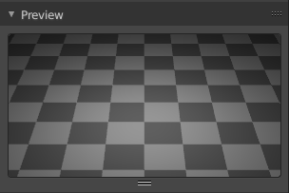
Provides a preview window for the light.

Light panel
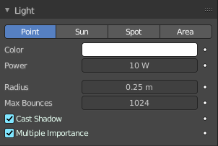
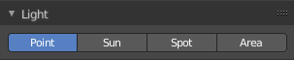
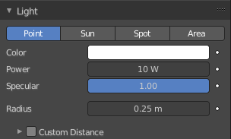
The light panel contains the settings for the different light types. Color, strength, and so on.

The content differs, depend and of the chosen renderer.

Some props can be animated by setting a keyframe with the Animate Property button behind.

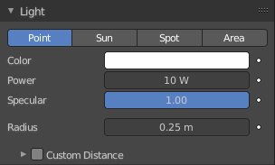
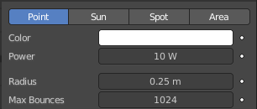
Point Light
The light emits from a point, and has falloff.

Color
The color of the light. Clicking at the color field will open a color picker.

Power
Power of the light in Watts. Higher values increase the intensity of the light. Negative values can be set, but should be avoided for predictable and physically based result.

Specular
Eevee renderer. Specular Light intensity multiplier.

Radius
When larger than zero, light will be emitted from a spherical surfaces with the specified radius. Lights with larger size have softer shadows and specular highlights.

Max Bounces
Cycles renderer. Maximum number of times light from the light is allowed to bounce. Limited by scene-wide bounce settings.

Custom Distance
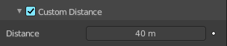
Eevee Renderer. If enabled uses Distance as the custom attenuation distance instead of global light threshold. In order to avoid long setup times, this distance is first computed automatically based on a light threshold. The distance is computed at the light origin and using the inverse square falloff.

Distance
The distance where light influence will be set to 0.

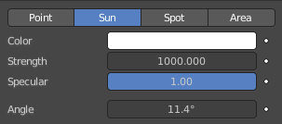
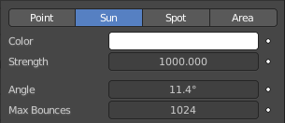
Sun Light
The light has no falloff, and goes into one direction.

Color
The color of the light. Clicking at the color field will open a color picker.

Strength
Strength of the light in Watts per square meter.

Specular
Eevee renderer. Specular Light intensity multiplier.

Angle
The size of the sun light according to its angular diameter as seen from earth.

Max Bounces
Cycles renderer. Maximum number of times light from the light is allowed to bounce. Limited by scene-wide bounce settings.

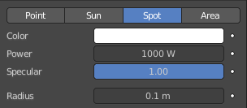
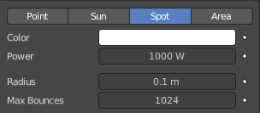
Spot Light
The light has falloff. And gets distributed in a cone shape.

Color
The color of the light. Clicking at the color field will open a color picker.

Strength
Strength of the light in Watts per square meter.

Specular
Eevee renderer. Specular Light intensity multiplier.

Radius
When larger than zero, light will be emitted from a spherical surfaces with the specified radius. Lights with larger size have softer shadows and specular highlights.

Max Bounces
Maximum number of times light from the light is allowed to bounce. Limited by scene-wide bounce settings.

Custom Distance
Eevee Renderer. If enabled uses Distance as the custom attenuation distance instead of global light threshold. In order to avoid long setup times, this distance is first computed automatically based on a light threshold. The distance is computed at the light origin and using the inverse square falloff.

Distance
The distance where light influence will be set to 0.

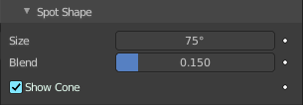
Spot shape
Eevee renderer.

Size
The size of the outer cone of a spot.

Blend
Blending to the inner cone of a spot. The inner cone boundary line indicates the point at which light from the Spot will start to blur/soften.

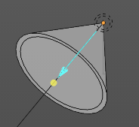
Show cone
Shows the cone opaque in the 3D view

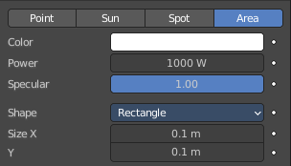
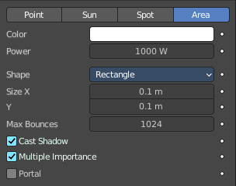
Area Light
The light emits from a surface, and has falloff.

Color
The color of the light. Clicking at the color field will open a color picker.

Power
Power of the light in Watts. Higher values increase the intensity of the light. Negative values can be set, but should be avoided for predictable and physically based result.

Specular
Eevee renderer. Specular Light intensity multiplier.

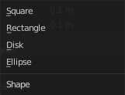
Shape
The shape of the light emitting surface.

Size X / Y
The size of the light emitting surface.

Max Bounces
Cycles renderer. Maximum number of times light from the light is allowed to bounce. Limited by scene-wide bounce settings.

Custom Distance
Eevee Renderer. If enabled uses Distance as the custom attenuation distance instead of global light threshold. In order to avoid long setup times, this distance is first computed automatically based on a light threshold. The distance is computed at the light origin and using the inverse square falloff.

Distance
The distance where light influence will be set to 0.

Portal
With Cycles Area lights can also function as light portals to help sample the environment light. This can significantly reduce noise in interior scenes. Light portals are not helpful for outdoor scenes. Since outdoor the light bounces just fly off into the sky.
Using the light as portal hides it.

Cast Shadow
Cycles renderer. The light source casts a shadow.

Multiple Importance
Cycles renderer. By default lights use only direct light sampling. Which can be noisy with sharp glossy reflections. Multiple Importance activates Indirect light sampling to reduce noise.

Light panel
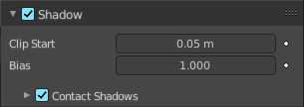
Eeevee renderer shadow settings. Eeevee is a realtime renderer. And in Eevee shadows are done with shadow maps.

Clip Start
Shadow clip start distance. A distance below will not generate a shadow.

Bias
The bias to reduce self shadowing.

Cascaded Shadow Map
Sun light only. Shadow large scenes by distributing multiple shadow maps over the frustum range. Each cascade covers a different portion of the view frustum. Note that cascade shadow maps are always updated because they are view dependent.
Note! In orthographic view the cascades cover the whole depth range of the camera with an evenly distributed shadow precision.

Count
Number of cascades to use. More cascades means better precision but a lower update rate.

Fade
Fade transition area between two cascades. Higher values means less overall resolution because cascades need to overlap.

Max Distance
Distance away from the view origin (or camera origin if in camera view) to cover by the cascade. If the view far clip distance is lower than Max Distance, the view far clip distance will be used. Only works in perspective view.

Distribution
Puts more resolution towards the near clip plane. Only works in perspective view.

Contact Shadows
Contact shadows exists to fix light leaking caused by bias or shadow map undersampling. The same limitations applies like for screen space reflections. Unknown object thickness and effect disappearing at screen edges.
Tip! Keep the distance of contact shadows small. They are not accurate enough to shadow the entire scene.

Distance
World space distance in which to search for screen space occluder.

Bias
Bias applied to the ray tracing to reduce self-shadowing artifacts.

Thickness
Pixel thickness used to detect occlusion, treating any potential occluder as this thick.

Spot Shape panel
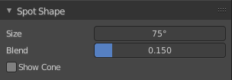

Size
The size of the outer cone of a spot.

Blend
Blending to the inner cone of a spot. The inner cone boundary line indicates the point at which light from the Spot will start to blur/soften.

Show cone
Shows the cone opaque in the 3D view.

Area Shape panel

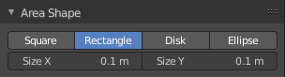
Workbench renderer. The shape and size of the Area light.

Nodes panel

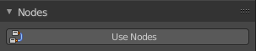
Use Nodes
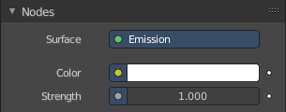
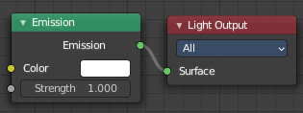
Use nodes for the light setup. Creates the standard nodes for an emission light. Which can be found in the Node editor then. Once activated the Nodes panel shows the content of the emission node.

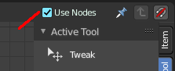
To revert, and not to use nodes, untick the Use Nodes checkbox in the node editor.

Custom Properties Panel


Here you can define custom properties that can be used for scripting.

Here you might also find custom properties from addons or scripts.

Add
Adds a new property.


Edit
Opens a panel where you can adjust the settings for the custom property.

Remove
Removes the property.

